Oct. 19 to Nov. 15, 2025, SUSTech, Shenzhen, China
Biomedical Engineering Laboratory I (Fall 2025)

Lab 3 Microfluidics

Group 5
姚子墨  12312221 | 吴赟戎  12313320

姜晨曦  12212109 | 涂昀烨  12313314

MATERIALS AND METHODS
In this laboratory, we finished a whole procedure from preparation to using, including lithographic fabrication, assembling device, testing laminar flow and modeling a microvascular network. Different materials are used in each part.
In procedure 1, Silicon wafer, spinner, 95°C hot plate, UV lamp, film mask, SU-8 2025 Photoresist, SU-8 Developer, Isopropanol, Wafer Tweezers are used to make a silicon wafer with target features.
We first put the wafer on the spinner and deposit more than 2 ml SU-8 2025 photoresist (PR) onto the center of the wafer. We ran the spinner at 500 rpm for 10 s and then 3000 rpm for 30 s to deposit an even layer of PR ~25 μm thick. The wafer is then baked at 95°C for 7 min.
Next step is to determine the pattern under a UV lamp. A film mask with specific patterns is put on the wafer, which is then exposed under UV lamp for 9s. Being exposed under UV light, PR became corsslinked. The exposed wafer is baked at 95°C for 7 min again.
The baked wafer is transferred into a container of SU-8 developer(in a chemical fume hood since its volatility). We kept gently agitating the container for about 10 minutes and rinse it with isopropanol. In this step, uncrosslinked PR is washed away while crosslinked PR remained on the wafer.
At last we dried the silicon wafer with nitrogen and bake it at 95°C for 2 hours. This helped further fix the micro-structure on the surface.
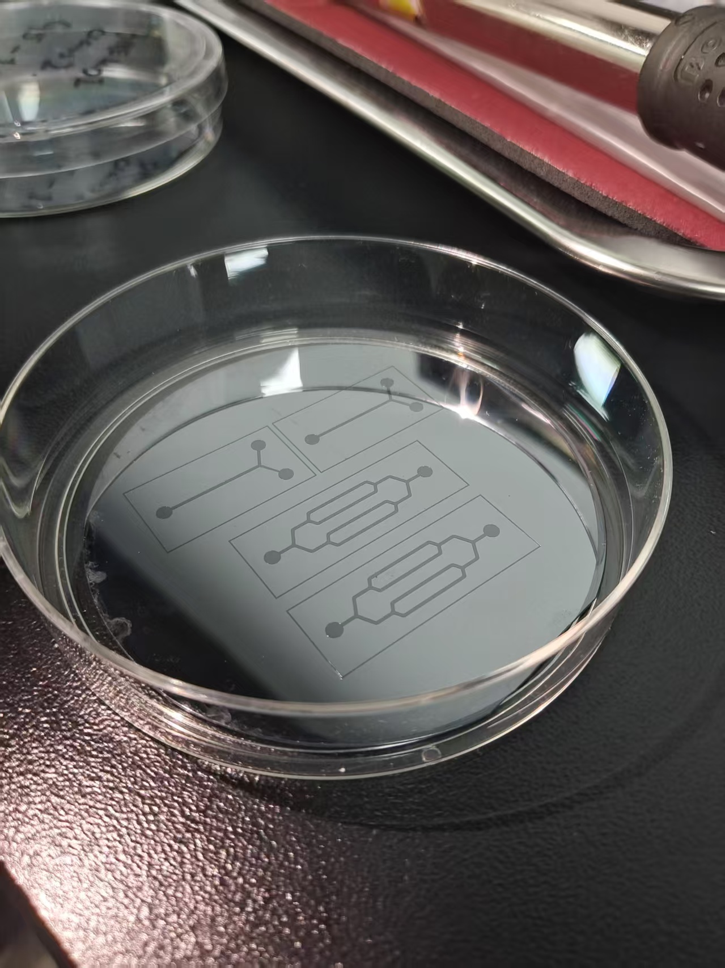
Figure 1: Silicon wafer with target feature

In procedure 2, we used PDMS (Dow Corning, Sylgarg 184), plastic cup, electronic balance, glass stirrer, petri dish (10 cm), silicon wafer with PR micro-structure, vacuum desiccator with pump, bake oven, knives and scrapers, 0.75 mm punch, plasma cleaner, microscope slide and scotch tape to mold a replica and stick it to a slide.
The Microfluidic Device is composed of a glass slide and a solidified PDMS channel. First we prepared the PDMS. We poured 50 g of PDMS base into a plastic cup, added 5 g of PDMS curing agent to the PDMS base, and vigorously mixed the two components thoroughly(2-equivalent). Then we degassed the mixture using a desiccator and vacuuming it. During degassing, we took out the mixture every 2-3 minutes and blew the surface with a rubber bulb to remove the bubbles near the surface. Next we transferred the mixture into a dish with silicon wafer and remove the bubbles again. The final mixture is then baked at 80°C for 1 hour.
Then we took out the solidified PDMS with a knife and a scraper. Each squared PDMS block has two or three places that need to be punched with a 0.75 mm-diameter punch. We made sure the hole is perpendicular to the surface and no cracks.
Next we connect the slide and the PDMS. Remove any dust from the PDMS using scotch tape. Clean the microscope slide with an ethanol wipe. Put the PDMS channel and slide into the plasma cleaner and turn on the cleaner. The clean sides are always facing up and bonded to each other. After bonding the pieces, we tapped the slides gently and baked them at 125°C for 30 min immediately.
In procedure 3, we test the channel and the laminar flow with steel and silicon tubing, 1 mL syringe, needles #6, scissors inverted microscope fluorescent, dye, deionized Water.
First we tested the channel with deionized water. We connected a steel tubing and a silicon tubing then insert the other end of steel tubing to the channel inlet/outlet. One end of silicon tubing is put into a reservoir of deionized water. We pulled the syringe and made sure the channel is smooth and no leakage.
Next we used the “Y” shape channel to test the laminar flow. After removing the bubbles, we put the tubes in to the DI water and the dye. Then we pulled the syringe gentle to mix the two liquids and observed them under a microscope. Reynolds number is used to judge the flow state, which is calculated by the equation:
$$Re=\frac{ρvd}{μ}$$
We assume that the diameter is d and the $μ$, $ρ$ of water and dye are the same. Here v is calculated by dividing the change in volume by the change in time(60 s).
Generally, if the Reynolds number is smaller than 2000 laminar flow occurs, while usually the Reynolds number in cell is smaller than 10. We calculated the number and verified it through the microscope.
In procedure 4, we measured the flowing velocity and modeling a microvascular network with Microbeads Suspension (9.0-9.9 $μ$m diameter), Beaker and Syringe Pump.
This time we use a channel with two holes(one inlet and one outlet).
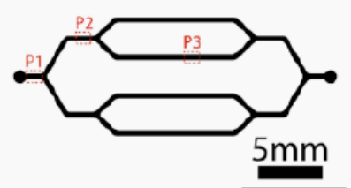
Figure 2: The microfluidic channel.
The basic procedure is the same as what we do in procedure 3, but this time we loaded the syringe with microbeads solution on the syringe pump and set the pump infuse 4 $μ$L/min. Also, during the pump working, we frequently knocked the syringe to avoid the aggregation of microbeads.
Then we observed the microbeads in different channels in the network (P1,P2,P3) and measured the beads number and beads velocity

